1. Concat the name and surname of the employees using the separador ‘ ‘ using the function CONCAT_WS.

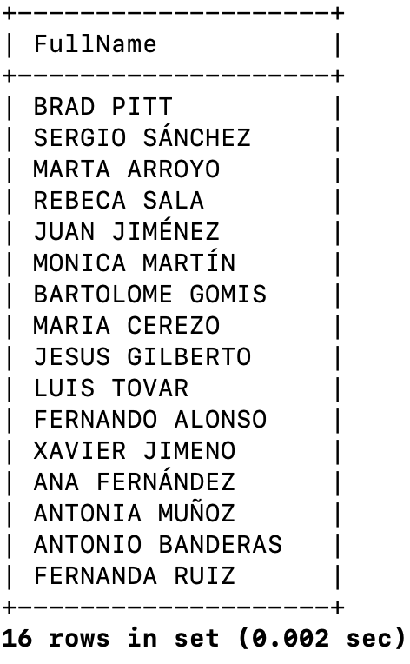

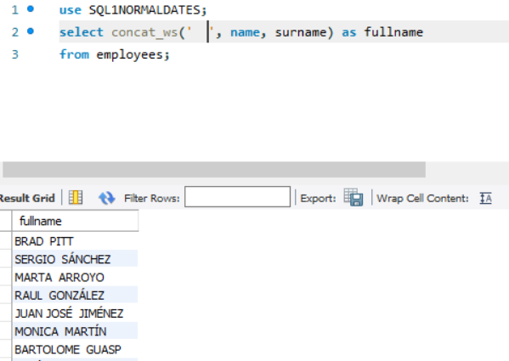

2. Format employees’ commission with format ##,## (you must check MariaDB docs, not only the slides…).

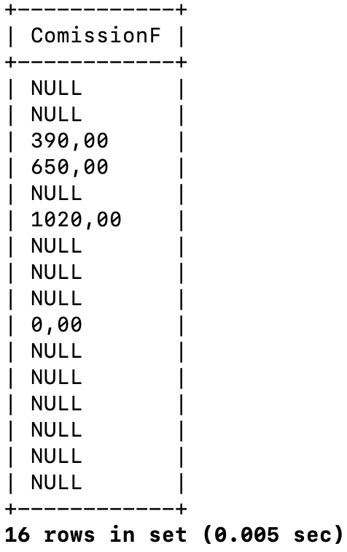

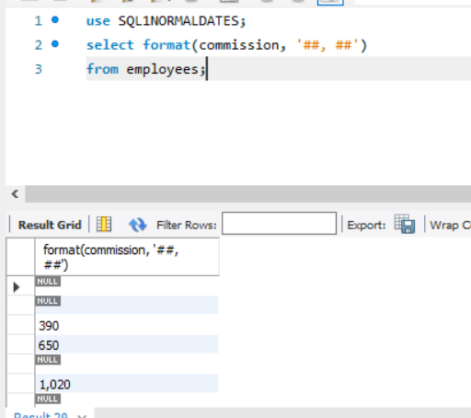

3. Return the position of the first A in the employees’ surname.

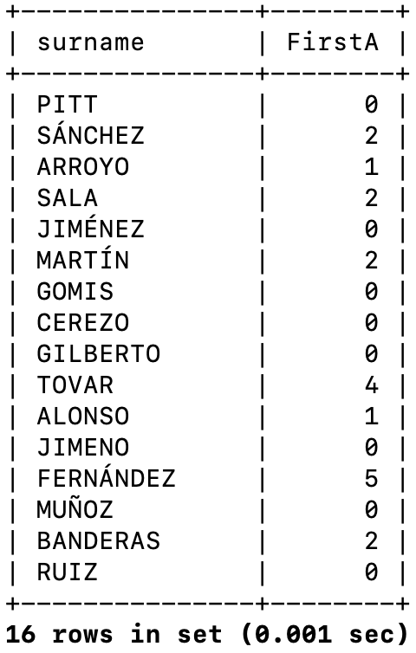

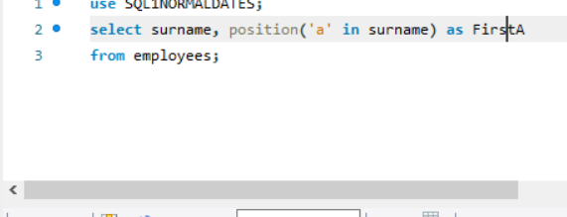

4. Return the position of the second A in the employees’ surname. Clue: Check [IF function](https://mariadb.com/kb/en/library/if-function/) and use nested functions SUBSTRING and INSTR.

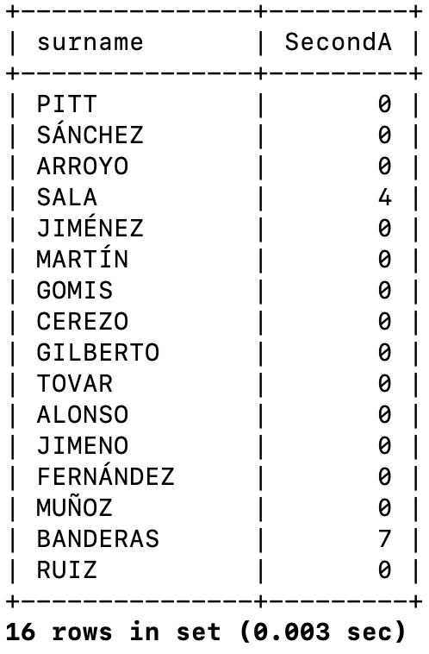

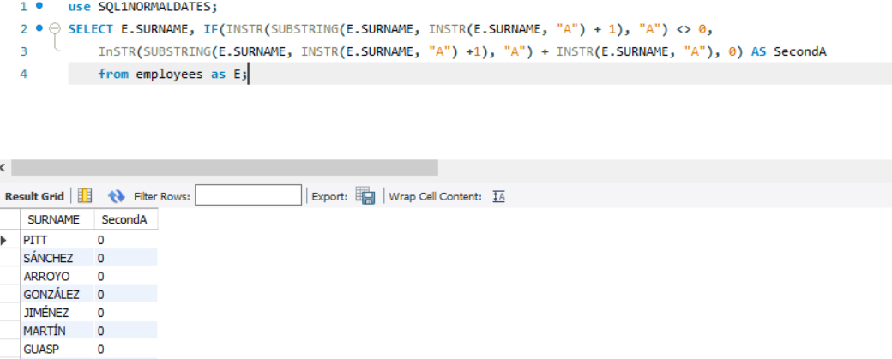

5. Return the full name of the employees with the next format:

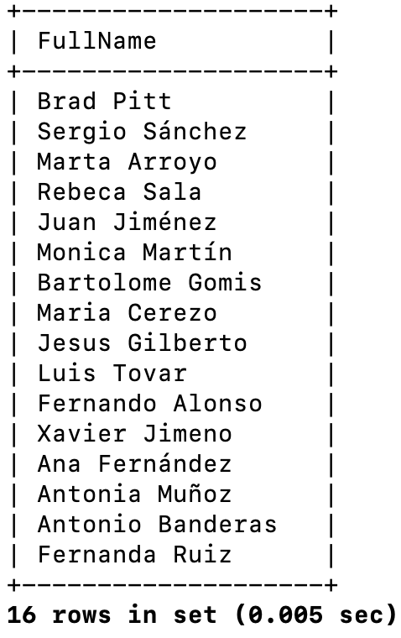

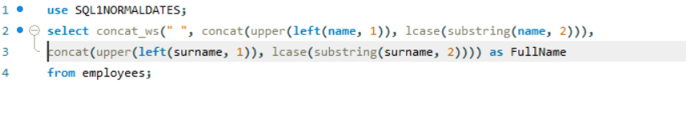

6. Select all the full names of the databases but changing ’IO’ for ‘IOTE’. If you do this using string function in a SELECT clause you don’t change the data stored in the database…

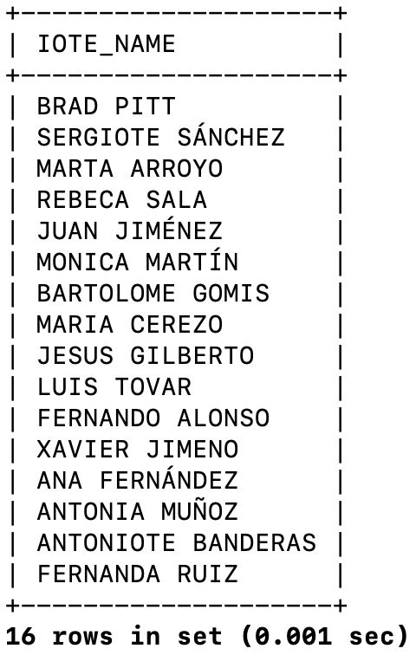

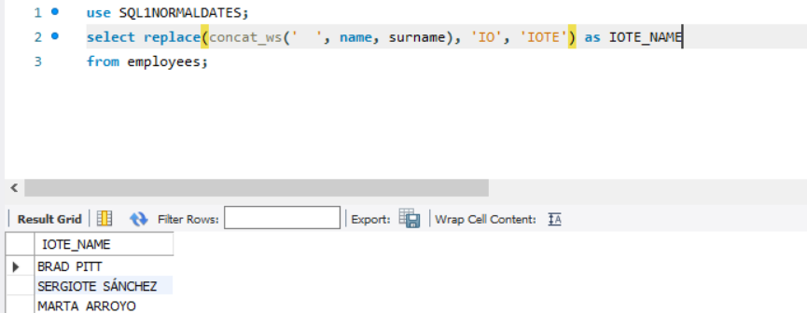

7. Update all the names like Antonio or Antonia with Tonio or Tonia. You must use UPDATE and the function REPLACE.

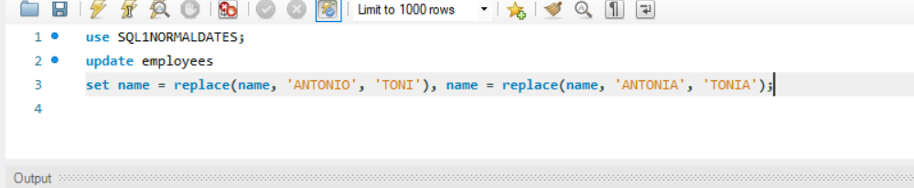

8. Show the surnames of the employees with an underscore after the second char.

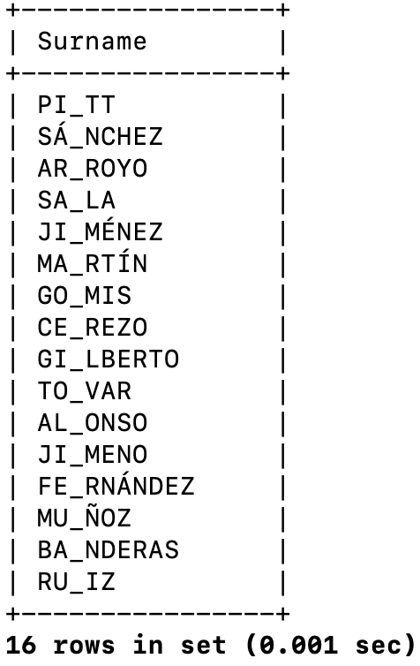

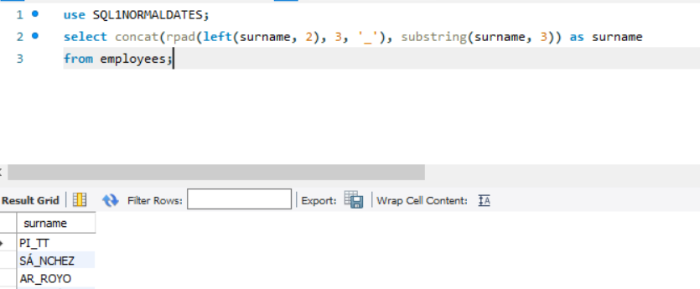

9. Write the first char of the surnames and the first char of the surnames in ASCII code.

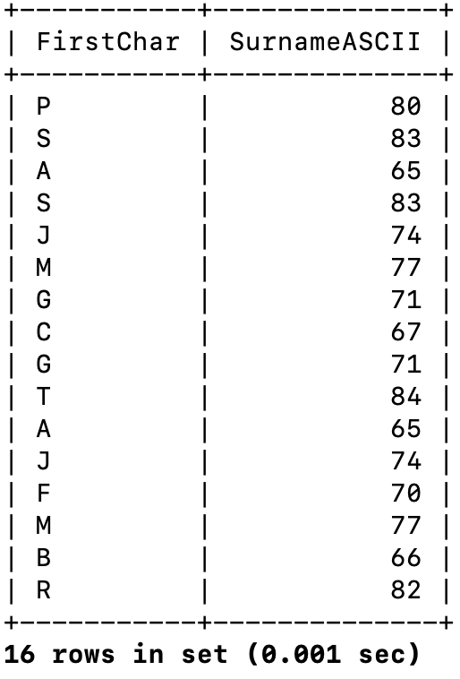

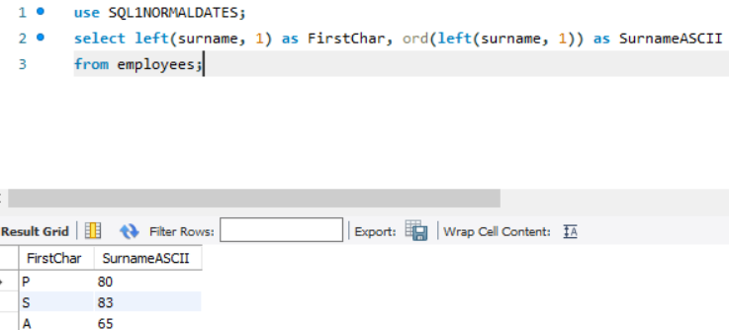

10. Show the full name of the employees but ensuring that there won’t be white spaces before and/or after the name and/or surname.

